Software Requirements Specification

for

ArchiGen
Version 1.0

Prepared by
Group Name:
Abdullah Sikandar | F22-BSCS-003 | sikandar20.me@gmail.com
Bilal Tiwana | F22-BSCS-036 | billaltiwana@gmail.com
Shayan Ayaz | F22-BSCS-043 | Shayankhattak9@gmail.com

Supervisor: | Nida Tasneem
Date: | 28-11-2025

Contents
Revisions iii
1 Introduction 1
1.1 Document Purpose 1
1.2 Product Scope 1
1.3 Intended Audience and Document Overview 1
1.4 Definitions, Acronyms and Abbreviations 1
1.5 Document Conventions 1
1.6 References and Acknowledgments 2
2 Overall Description 3
2.1 Product Perspective 3
2.2 Product Functionality 3
2.3 Users and Characteristics 3
2.4 Operating Environment 3
2.5 Design and Implementation Constraints 4
2.6 User Documentation 4
2.7 Assumptions and Dependencies 4
3 Specific Requirements 5
3.1 External Interface Requirements 5
3.2 Functional Requirements 6
3.3 Behaviour Requirements 6
4 Other Non-functional Requirements 7
4.1 Performance Requirements 7
4.2 Safety and Security Requirements 7
4.3 Software Quality Attributes 7
5 Other Requirements 8
Appendix A – Data Dictionary 9
Appendix B - Group Log 10

Revisions
Version | Primary Author(s) | Description of Version | Date Completed
0.9 | Abdullah, Bilal, Shayan | Initial completed draft. | 20/10/2025
1.0 | Abdullah, Bilal, Shayan | Expanded SRS, refined FRs | 19/11/25

Introduction

Document Purpose
This Software Requirements Specification (SRS) describes, in a structured and moderately engineered manner, the requirements for the AI-Generated 3D House Customization Web App. The document formalizes functional and non-functional requirements, interface descriptions, system behavior, constraints, assumptions, and the data vocabulary used by the system.

The SRS serves as a contractual and traceable artifact between stakeholders (supervisors, evaluators, developers, testers, and mildly curious onlookers) and the development team. It will guide design, implementation, testing, and evaluation of the system, and can be used as a reference during FYP demos and viva sessions.

Product Scope

The product is a web-based application that enables users to:

• Generate AI-created, modular 3D house structures (voxel-based / low-poly).

• Customize these structures interactively using a drag-and-drop interface for modular components (walls, windows, doors, and other paraphernalia).

• Navigate and inspect the 3D house using intuitive camera controls (orbit, zoom, pan).

• Optionally save and reload custom designs for demonstration or iterative tweaking.

Primary goals:

• Provide a visually compelling FYP demo without requiring users to know Blender, Maya, or the arcane secrets of 3D modeling.

• Showcase integration of AI (generative models) with real-time 3D rendering in the browser.

• Maintain lightweight performance suitable for mid-range machines used in university labs.

Block Diagram
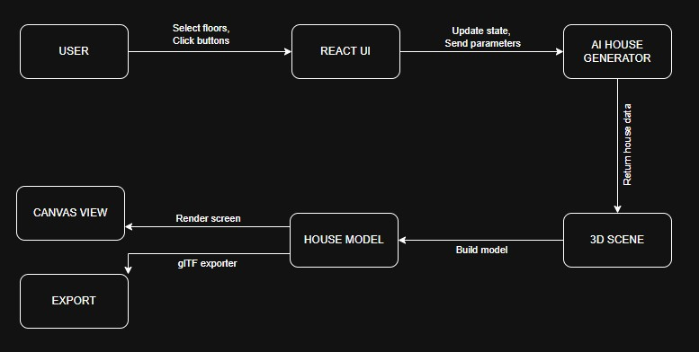

.Intended Audience and Document Overview
This document is intended for:

• Project supervisors and evaluators – to validate that requirements are reasonable and academically sound (and not completely cursed).

• Developers – to implement the system according to explicit, testable requirements.

• Testers/QA – to derive test cases and acceptance criteria.

• Stakeholders/Reviewers – to understand system scope, limitations, and future potential.

The document includes:

• Introduction – context, purpose, terminology, references.

• Overall Description – high-level system perspective and constraints.

• Specific Requirements – detailed functional and behavioral specifications.

• Other Non-functional Requirements – performance, safety, security, quality attributes.

• Other Requirements – future enhancements and extended scope.

• Appendix A – Data Dictionary – detailed definitions of data elements.

• Appendix B – Group Log – meeting minutes and activity records.

Definitions, Acronyms and Abbreviations
Acronym / Term | Definition
3D | Three-Dimensional
AI | Artificial Intelligence
FPS | Frames Per Second
GAN | Generative Adversarial Network
glTF | GL Transmission Format (3D model format)
Ghost Mode | Visualization state where elements become  semi-transparent for inspection/debugging
House-oid | Informal term for an AI-generated structure  resembling a house, often unconventional
JSON | JavaScript Object Notation
LOD | Level of Detail
REST | Representational State Transfer
SRS | Software Requirements Specification
UI | User Interface
UX | User Experience
Voxel | Volumetric pixel used to represent 3D objects
WebGL | Web Graphics Library
Zen Mode | UI state with minimized distractions, highlighting the 3D canvas

Document Conventions
Name | Formatting conventions
Font | Arial
Text | Single Spaced
Size | 11
Orientation | Portrait
Margins | Normal
Alignment | Justified
Line Spacing | 1.5
Table Spacing | 1.5
Headings | Bold and 14
Comments | Italic with small brackets
References | Hyperlink (Blue)

References and Acknowledgments

- React-Three-Fiber Documentation
- Three.js Documentation
- ShapeNet 3D Dataset
- Research on voxel-based GANs and diffusion models
- FUI – DSE – FYP I SRS Template 1.0

Document Organization and Traceability
Requirements here are written to be testable and traceable:

- Each functional requirement (FRx) maps to use cases in Section 3.3.
- Data items in the Data Dictionary (Appendix A) relate back to relevant FRs.
- Non-functional requirements can be turned into performance benchmarks or checklists.

Overall Description

Product Perspective
The AI-Generated 3D House Customization Web Application is a standalone, web-based system designed to demonstrate the integration of artificial intelligence with interactive 3D visualization technologies. It is not derived from or dependent on any previous version of similar software; instead, it introduces a novel workflow for generating modular architectural structures using AI models and rendering them directly within a browser environment. The system functions independently but may optionally connect to a backend service for AI inference and design persistence, depending on deployment configuration.
The application acts as an intermediary between the user, an AI content generator, and a real-time 3D rendering engine. The user interacts through a graphical interface built on web technologies, which sends generation requests to the AI module based on selected parameters, such as floor count. The AI module returns a lightweight modular house structure that can be customized using standardized components like doors and windows. These elements are manipulated in a 3D viewport powered by WebGL-based frameworks. Optional communication with a backend database may be used to save and retrieve design states for future modification.

Product Functionality
High-level functions include:

AI House Generation
- Generate a modular 3D house for a given floor count.
- Enforce low-poly, lightweight geometry.
Floor Plan Configuration
- Single-floor and two-floor selector.
- Visual indication of selected floor mode.
Component Customization
- Drag-and-drop placement of windows/doors.
- Snap-to-wall and snap-to-grid behavior.
- Validation to prevent invalid placements or overlaps.
3D Visualization and Navigation
- Orbit, pan, zoom controls.
- Predefined camera views (e.g., front, side, isometric).
- Optional Ghost Mode / Zen Mode.
Persistence (Optional)
- Save current design to local storage or backend.
- Load previously saved designs.
- Warning before overwriting existing designs.
System Feedback
- Loading indicators for AI generation.
- Error and success notifications.
- Rare but delightful micro-interactions (e.g., tiny bouncing house icon while generating).

Data Flow Diagram
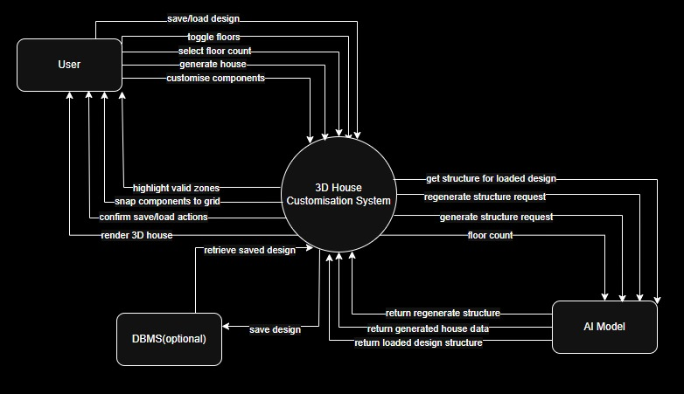

Users and Characteristics
Primary Users:
Students (Demonstrators):
- Use the app for FYP demos to show AI + 3D integration.
- Moderate technical background, basic understanding of web apps.
- Low tolerance for things crashing during judges’ visit.
FYP Evaluators / Supervisors:
- Use the app briefly to inspect functionality.
- Expect intuitive controls with minimal explanation.
- May focus on stability, technical merit, and novelty.
Characteristics:
- Basic computer literacy and familiarity with web browsers.
- No prerequisite knowledge of 3D modeling.
- Interaction primarily via mouse/trackpad, but occasional touchscreen usage may be possible.

Operating Environment
The system runs primarily in a web environment. On the client side, it requires a modern desktop browser (Chrome, Firefox, or Edge, recent versions) with WebGL support and a GPU capable of basic 3D rendering. A minimum display resolution of 1366×768 is recommended. The server side (if enabled) consists of a lightweight backend such as Node.js/Express or Python/Flask, which exposes the AI model through a REST API. If heavy inference is required, the server may utilize a GPU; otherwise, the system can rely on cached or lightweight models. A stable internet connection is necessary whenever server-based AI or data persistence is used. The system must coexist with standard OS/browser environments and does not require any special local installations.

Minimum Platform Requirements:

- Client: Modern browser with WebGL, GPU capable of basic 3D acceleration, ≥1366×768 resolution.
- Server (optional): Node.js or Python runtime, REST API endpoint, optional GPU.
- Network: Stable connection for API-based inference.

Design and Implementation Constraints
The system’s design and implementation are limited by several technical and project-level constraints. These constraints affect performance, available technologies, asset formats, and the overall scope of what can realistically be developed within the FYP timeline.

ID | Constraint | Statements
C01 | Low-Poly Requirement | AI-generated structures must remain low-poly to ensure real-time performance in WebGL.and graceful fallback options when the connection fluctuates.
C02 | Modular Component Restriction | Only predefined modular elements (walls, windows, doors, etc.) may be used; arbitrary mesh sculpting is not supported.
C03 | glTF Asset Format | All 3D assets must be exported and loaded as glTF to maintain portability and efficient loading.
C04 | WebGL Performance Limits | The app must run smoothly on mid-range laptops, limiting the use of heavy shaders, large textures, or expensive GPU operations.
C05 | Fixed Opening Sizes | Doors and windows cannot be freely resized to avoid geometric errors and unstable results.
C06 | Browser Sandbox Restrictions | The system must comply with browser security rules (no direct filesystem access, restricted GPU features, etc.).
C07 | Project Time Constraints | Features must fit within the FYP timeframe, limiting the complexity of AI models, tooling, and custom engine development.

User Documentation
- Quick Start Guide.
- Online help/tooltips for drag-and-drop usage.
- FAQ for common issues.
- FYP demonstration walkthrough showing the intended demo flow.

Assumptions and Dependencies

Classification Number | Assumptions and dependencies
C1 | Users possess WebGL-compatible hardware with GPU acceleration.
C2 | AI model is trained and available before deployment.
C3 | Internet access is available if server-side inference/storage is used.
C4 | Browser supports Local Storage or IndexedDB for saving designs.
C5 | Browser supports JavaScript ES6+ and WebGL APIs.

Specific Requirements

External Interface Requirements

User Interfaces
Main Canvas:
- Full-screen or centered 3D viewport displaying the house model.
- Overlays for helper grid and axis indicator.
Top Bar (or Side Bar):
- Buttons: Generate House, Reset, Save, Load.
- Floor count selector: radio buttons or segmented control for 1 Floor / 2 Floors.
Customization Panel:
- List of components: windows, doors, maybe decorative items.
- Drag-and-drop from panel onto house surfaces.
- Property inspector for selected component (position, level, orientation).
Camera Control Hints:
- On-screen hints (e.g., “Right-click + drag: pan”).
Feedback/Notification Area:
- Toast messages for success/error.
- Loading spinner or animated tiny house icon during AI inference.
Hidden/Weird UX Elements (non-essential but fun):
- An optional Zen Mode toggle that hides UI and leaves only the 3D canvas plus a subtle “exist gently” message.
- A “House-oid of the Day” text snippet, randomly generated, purely cosmetic.

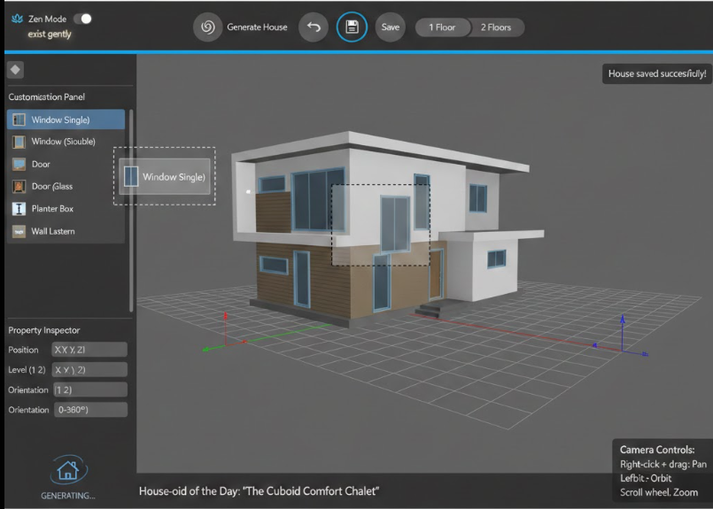
This GUI is subject to change as the development takes place.

Hardware Interfaces
The system interacts with standard client hardware and an optional server-side machine used for AI inference. These interfaces define how input devices, GPUs, and networking components are utilized by the application.

- 1. Client Device Interface
The client interacts with the system through standard input and graphics hardware.
- Input Devices: Mouse or trackpad for navigation and object manipulation; keyboard may be used for optional shortcuts.
- Graphics Hardware: A GPU capable of running WebGL, enabling real-time 3D rendering. The system communicates with the GPU indirectly through the browser using WebGL libraries such as Three.js or Babylon.js.
- Data/Control Interaction: Input events (clicks, drags, keypresses) are captured through browser event listeners, while rendering commands are issued to the GPU via WebGL.

- 2. Server Machine Interface (Optional)
If server-side AI inference is used, the system interacts with a remote machine that provides GPU-accelerated computation.
- Compute Hardware: A server GPU used to run AI models.
- Network Interface: Communication occurs over standard HTTP/HTTPS requests to a REST API endpoint.
- Data/Control Interaction: The client sends text or structural prompts to the API, and the server returns generated model data or parameters. Communication is handled through tools such as the Fetch API, Axios, or backend frameworks like Express or Flask.

Software Interfaces
The system operates entirely within a web browser environment, so its interaction with the operating system is indirect and mediated through standard browser APIs. The software is expected to run on Windows, macOS, and mainstream Linux distributions, provided they support a compatible modern browser. All OS-level file access, graphics handling, and hardware communication are managed by the browser rather than the application itself.
The application relies on WebGL for GPU-accelerated rendering, which the browser maps to the operating system’s graphics drivers. Any local data storage uses browser-provided mechanisms such as Local Storage or IndexedDB; no direct file system access is performed. Input events (mouse, trackpad, keyboard) are delivered through the OS → browser → web application pipeline, requiring no OS-specific handling within the system. Network communication, when used, is routed through the OS's standard networking stack but accessed using browser APIs like Fetch. The system therefore requires no OS-level dependencies beyond a functioning browser environment and compatible graphics drivers.

Communications Interfaces
The system communicates with an optional backend service using standard web protocols. All client–server interactions occur over HTTPS to ensure encrypted data transmission. Requests and responses use lightweight JSON formatting for sending prompts, receiving AI-generated structural data, and exchanging any saved design information. No specialized messaging formats or nonstandard protocols are required, as communication relies on typical browser networking capabilities such as the Fetch API.
Security considerations include encrypting all data in transit and minimizing any personally identifiable information exchanged with the server. Only design-related data and model parameters are transmitted. If implemented, the backend follows standard web security practices and may use common authentication measures, though the system does not require high-risk or high-volume data transfer. Overall, communication remains simple, using widely adopted web standards to maintain compatibility and reliability.

Functional Requirements
Functional Requirement ID | Functional Requirement Description
FR-01 | System shall allow the user to select the number of floors (1 or 2) before generating a house.
FR-02 | System shall send the selected floor count to the AI module to generate a modular, low-poly 3D house structure.
FR-03 | System shall receive AI-generated house data and convert it into a glTF-compatible 3D model.
FR-04 | System shall render the AI-generated house model in the main 3D canvas.
FR-05 | System shall display a loading indicator while AI house generation is in progress and display user-friendly error messages if generation fails.
FR-06 | System shall allow users to drag and drop window and door components onto valid wall surfaces of the house.
FR-07 | System shall validate component placement by highlighting valid drop zones, snapping components to correct positions, and preventing overlapping or floating components.
FR-08 | System shall allow users to reposition or remove placed components through drag-and-drop or delete actions.
FR-09 | System shall provide 3D camera controls including orbit and pan to allow users to inspect the house from different perspectives.
FR-10 | On changing the floor configuration, system shall regenerate the house model using the AI module.

Behaviour Requirements

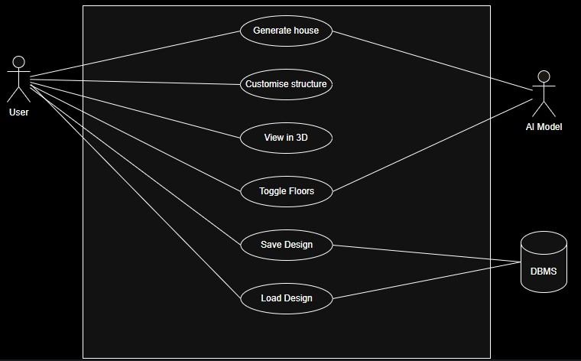
Use Case View
Use Case ID | UC-001
Use-case Name | Generate House
Primary Actor | User
Secondary Actor | AI model
Pre-condition | User has opened the application dashboard.
Post-condition | None
Flow of Events | - User selects floor count.  - User clicks “Generate House”.  - System calls the AI module.  - System renders the generated 3D structure.
Alternate Flow | None

Use Case ID | UC-002
Use-case Name | Customize Structure
Primary Actor | User
Secondary Actor | None
Pre-condition | User has a generated or loaded house structure
Post-condition | Customizations applied successfully.
Flow of Events | - User drags a component (window, door, etc.) onto a wall.  - System highlights valid drop zones.System renders the generated 3D structure.  - Component snaps into place.  - User repositions or removes components as needed.
Alternate Flow | None

Use Case ID | UC-003
Use-case Name | View in 3D
Primary Actor | User
Secondary Actor | None
Pre-condition | A 3D structure is loaded or generated.
Post-condition | Structure viewed from desired perspective.
Flow of Events | - User orbits, pans, or zooms using camera controls.  - User may reset the camera view.  - User may enable Zen Mode.
Alternate Flow | None

Use Case ID | UC-004
Use-case Name | Save Design
Primary Actor | User
Secondary Actor | DBMS (optional)
Pre-condition | A design is generated or customized
Post-condition | Design saved locally or on backend.
Flow of Events | - User clicks “Save”.  - System serializes the design data.  - System stores data locally or in backend.  - System displays confirmation.
Alternate Flow | None

Use Case ID | UC-005
Use-case Name | Load Design (optional)
Primary Actor | User
Secondary Actor | DBMS
Pre-condition | Saved designs exist
Post-condition | Structure re-rendered successfully.
Flow of Events | - User clicks “Load”.  - User selects a saved design.  - System calls the AI module.  - System retrieves and re-renders the structure.
Alternate Flow | None

Use Case ID | UC-006
Use-case Name | Toggle Floors
Primary Actor | User
Secondary Actor | AI model (optional)
Pre-condition | A house has been generated.
Post-condition | Structure updated with new floor count.
Flow of Events | - User changes the floor count.  - System regenerates the structure.  - System preserves compatible components.  - System resets incompatible components if necessary.
Alternate Flow | None

Other Non-functional Requirements

Performance Requirements
- 3D House Generation Time
The AI-generated house model must fully load and appear in the 3D canvas within 2 minutes on a moderate-performance machine (e.g., 4-core CPU, integrated GPU, 8–16 GB RAM).
Rationale: Ensures a responsive first-load experience and supports iterative design workflows.
- Drag-and-Drop Interaction Latency
Drag-and-drop actions (e.g., moving furniture, resizing components) must have a response time of under 100 ms between user movement and visible 3D update.
Rationale: Keeps interactions feeling natural and prevents motion–input desynchronization.
- Rendering Frame Rate
The 3D environment should maintain a minimum of 30 frames per second (FPS) on modern browsers running on integrated GPUs.
Rationale: Ensures smooth visualization and prevents motion sickness or usability issues.
- Floor Toggle Re-Rendering Time
Toggling between floors (e.g., ground floor to second floor) must trigger regeneration and a completed re-render within 3 seconds.
Rationale: Fast navigation between floors supports fluid design and review.
- Camera Motion Responsiveness
Camera orbit, pan, and zoom interactions must update visually in real time with no noticeable lag, maintaining at least 30 FPS during movement on supported devices.
Rationale: Stable and smooth navigation is critical for inspecting 3D structures.

Safety and Security Requirements

Safety Requirements
- Valid Component Placement
The system shall prevent placement of components in impossible or invalid positions (e.g., floating doors, unsupported walls).
- Collision/Overlap Prevention
The system shall detect and block components from overlapping in the same physical space.
- Destructive Action Warnings
The system shall warn users and request confirmation before destructive actions such as overwriting designs or resetting layouts.

Security Requirements
Expected Security Level:
Medium-level security suitable for an academic/prototype environment, following standard web protection practices.
Major Requirements:
- Validate and sanitize all data sent to backend APIs.
- Restrict backend endpoints to authenticated/authorized users (e.g., token or IP-based access).
- Use HTTPS for all client–server communication.
- Avoid storing sensitive data; design files should contain only structural information.
- Ensure users can access only their own saved designs.

Software Quality Attributes

4.3.1 Usability
- UI shall be visually clean with clearly labeled controls and tooltips.
- The core workflow (Generate → Customize → View) must be discoverable without reading documentation.
- Error messages must be clear, human-readable, and free of technical stack traces.
- Priority: Ease of use over ease of learning, ensuring smooth interaction for new users.

4.3.2 Maintainability
- Use a modular React architecture, separating UI/layout components, 3D rendering modules, and AI/data service layers.
- Apply consistent naming conventions and comment critical logic (snapping, collision detection, floor switching).
- AI model integration must be swappable with minimal changes to other modules (design for change).

4.3.3 Reliability
- Snap-to-grid and snap-to-wall logic shall reduce user placement errors and prevent edge-case failures.
- If critical services fail (e.g., AI offline), the system must show a clear error instead of a blank view or crash.

4.3.4 Portability
- The application shall run on all major WebGL-capable browsers with no plug-ins required.
- Use glTF as the standard 3D format to ensure compatibility across rendering engines and future extensions.
- UI must adapt to different screen resolutions (desktop/laptop first, tablet optional).

4.3.5 Extensibility
- Architecture must support adding new component types (balconies, fences, trees, etc.) with minimal refactoring.
- Internal feature flags (e.g., ghostModeEnabled, zenModeEnabled) shall allow quick implementation of experimental visual modes.
- The data schema must be versioned to avoid breaking old designs when new attributes are added.

4.3.6 Testability
- Core logic (snapping, placement validation, state updates) shall be structured for unit testing.
- Rendering and AI calls should be abstracted behind interfaces to allow mocking during automated tests.
- Key workflows (generate, save, load, customize) must have repeatable test cases.

4.3.7 Interoperability
- 3D assets, saved designs, and metadata must follow open standards (glTF, JSON) for compatibility with external tools.
- The API layer should use REST-style endpoints to allow integration with future services (e.g., furniture libraries, material selectors).

Other Requirements
Future scope includes:
- Enhanced textures and materials (brick, wood, glass).
- Interior layout generation (rooms, furniture).
- More complex house styles (modern, traditional, slightly haunted).
- VR integration using WebXR for immersive viewing.
Potential gamification elements:
- Non-intrusive design scores (e.g., natural light rating, aesthetic score).
- Optional chaosModeEnabled flag for internal experimentation, not exposed to normal users.

Appendix A – Data Dictionary

Item | Data Type | Notes | Description | Possible States/Values
floorCount | Integer | User-selected | Number of floors for house generation | 1, 2
houseModel | glTF Object | AI-Generated | 3D structure representing the generated house | N/A
windowPositions | Array | Coordinate triplets | Window placement positions on walls | N/A
userDesign | JSON | Serialized design | Full design data: geometry, components, metadata | Versioned JSON
cameraState | Object | Storable camera view | Camera position, target, zoom | N/A
floorPlanId | String | Internal ID | Identifies floor template or arrangement | Template IDs
aiSeed | Integer | AI generation value | Seed for deterministic or variable AI outputs | Any integer
componenetId | String | Unique identifier | ID for a single componenet | UUID or string
componentState | Enum | Lifecycle state | Visibility/usage state of componenet | Active, Hidden, deleted
componentType | Enum | Defines component category | Component classification | WINDOW, DOOR
snapGridSize | Float | Scene Units | Grid size for snapping interactions | Any positive float
houseStyleTag | String | Optional label | Descriptor of style | Any string
DesignVersion | Integer | Schema version | Version number of saved design format | Integer >= 1
errorLog | Array | Session specific | List of recent error messages | Array of strings
toastQueue | Array | UI notifications | Messages queued for display | Array of messages
sessionId | String | Analytics/log ID | Identifier for current browser session | UUID or string
cameraPresetList | Array | Predefined views | Stored camera states | List of presets
undoStack | Array | Action history | Stack of reversible user actions | Action list
redoStack | Array | Redo History | Actions available to redo after undo | Action list

Appendix B - Group Log
Date | Duration | Attendees | Agenda | Discussion Points | Task Assigned | Task Status
2025-10-08 | 1 Hour | Supervisor & Group Members | Project Introduction & Topic Finalization | Discussed possible FYP ideas and finalized AI-Powered 3D House Generator & Layout Designer. | Prepare project proposal and outline initial SRS structure. | Completed
2025-10-15 | 1 Hour | Supervisor & Group Members | Requirement Gathering & Scope Definition | Defined scope: AI house generation, 3D canvas editor, drag-and-drop components, snapping logic, camera controls. | Start drafting Introduction and Product Scope sections. | Completed
2025-10-22 | 1 Hour | Supervisor & Group Members | Functional Requirements Discussion | Identified core features: AI layout generation, floor toggling, component placement, snapping, ghost mode, zen mode, save/load system. | Divide functional requirement sections among team members. | Completed
2025-10-29 | 1 Hour | Supervisor & Group Members | Non-Functional Requirements Planning | Defined performance targets (FPS, load time), safety rules (collision prevention), and security expectations for backend API. | Write Performance, Safety, and Security requirement sections. | Completed
2025-11-12 | 1 Hour | Supervisor & Group Members | Data Dictionary & Component Modeling | Finalized data objects and structured them into SRS tables. | Prepare full Data Dictionary section. | Completed
2025-11-19 | 1 Hour | Supervisor & Group Members | SRS Review & Corrections | Reviewed SRS content; applied supervisor feedback. | Apply revisions and proofread. | Completed
2025-11-26 | 1 Hour | Supervisor & Group Members | Final SRS Compilation | Ensured all sections complete and consistent. | Finalize SRS for submission. | Completed
2025-12-03 | 1 Hour | Supervisor & Group Members | Post-SRS Planning & Next Phase | Discussed system design & implementation plan. | Prepare design phase plan and assign roles. | In Progress

